Gridless Wireless Network

Functional Decomposition Diagram

**Team name**:

Off the Grid

**Team members:**

Ian Schneier

Linda Palacios

Weikang Zhang

Xucheng You

Jingwen Luo

Alec Motazedi

**Project Sponsor:**

### Prof. Alan Mickelson

# 

# 

## ***Level 0***

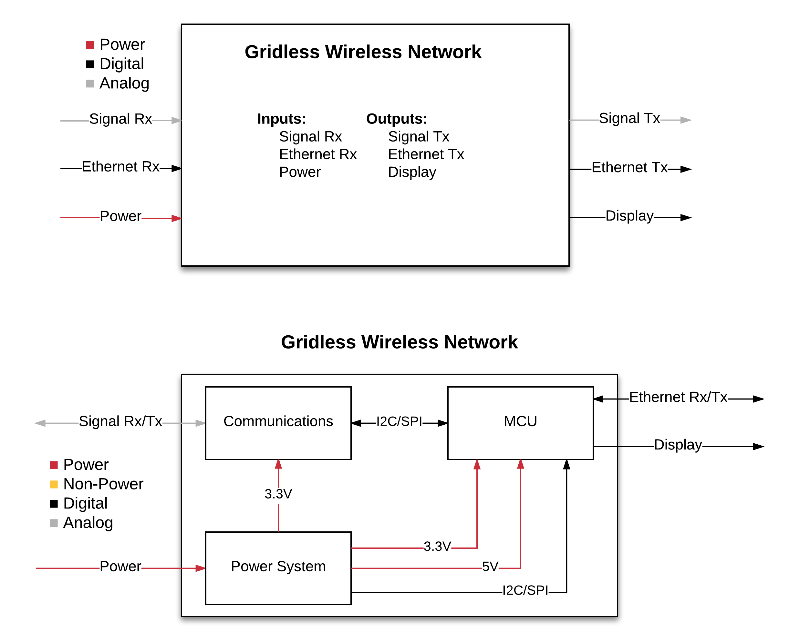

|  |  |
| --- | --- |
| Inputs | Signal Rx, Ethernet Rx, and Power |
| Outputs | Signal Tx, Ethernet Tx, and Display |
| Description | The Gridless Wireless Network (G.W.N.) provides a wireless internet connection areas where a natural disaster has occurred or in communities without Internet access |

# 

# 

# 

## ***Level 1***



|  |  |
| --- | --- |
| **Module** | **Communications** |
| Inputs | Signal Rx, I2C/SPI from MCU |
| Outputs | Signal Tx, I2C/SPI to MCU |
| Functionality | Receive and transmit data through wifi |

|  |  |
| --- | --- |
| **Module** | **Power system** |
| Inputs | Power (if charging) |
| Outputs | Multiple Voltage Levels, Battery Status |
| Description | Provide power to components |

|  |  |
| --- | --- |
| **Module** | **MCU** |
| Inputs | Multiple Voltage Levels(3.3V, 5V), I2C/SPI from Communications, I2C/SPI from Power System, Ethernet Rx |
| Outputs | Display, I2C/SPI to Communications, Ethernet Tx |
| Description | Interprets and sends information from the communications module, presents information on display, and communicates with Ethernet connections. |

# 

## ***Level 2***

## ***MCU***

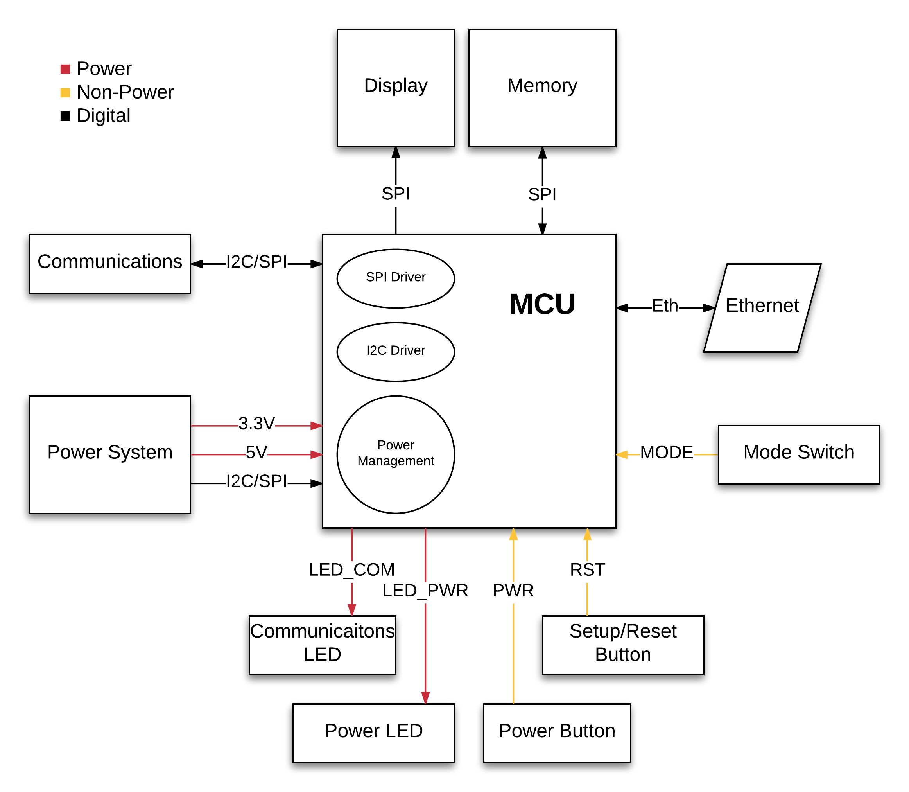

|  |  |
| --- | --- |
| **Component** | **MCU** |
| Inputs | Power Button, Setup/Reset Button, power system I2C/SPI data connection, 5V and 3.3V power, SPI from Memory, Eth, SPI to Communications |
| Outputs | Power LED, Communications LED, 2x Ethernet Ports, SPI to Memory, SPI to Communications |
| Description | The component responsible for facilitating data transmission via the transceiver and ethernet connections. Stores information on the Memory unit. |

|  |  |
| --- | --- |
| **Component** | **Display** |
| Inputs | SPI from MCU |
| Outputs | n/a |
| Description | Display to read out important information such as bandwidth usage, number of users connected, battery life, etc. |

|  |  |
| --- | --- |
| **Component** | **Memory** |
| Inputs | SPI from MCU |
| Outputs | SPI to MCU |
| Description | Stores data collected by the MCU as well as other software. |

|  |  |
| --- | --- |
| **Component** | **Ethernet** |
| Inputs | SPI from MCU |
| Outputs | SPI to MCU |
| Description | Ethernet port that allows device to access a wired local area network. |

|  |  |
| --- | --- |
| **Component** | **Setup/Reset Button** |
| Inputs | n/a |
| Outputs | RST |
| Description | Push Button to send the RST signal to start/restart the wireless internet protocol. |

|  |  |
| --- | --- |
| **Component** | **Power Button** |
| Inputs | n/a |
| Outputs | PWR |
| Description | Push Button to toggle the device on or off. |

|  |  |
| --- | --- |
| **Component** | **Power LED** |
| Inputs | LED_PWR |
| Outputs | n/a |
| Description | LED that emits light when the device is powered on. |

|  |  |
| --- | --- |
| **Component** | **Communications LED** |
| Inputs | LED_COM |
| Outputs | n/a |
| Description | LED that emits light when the device is transmitting a wireless network. |

|  |  |
| --- | --- |
| **Component** | **Mode Switch** |
| Inputs | n/a |
| Outputs | MODE |
| Description | Switch that determines what |

## 

## ***Power System***

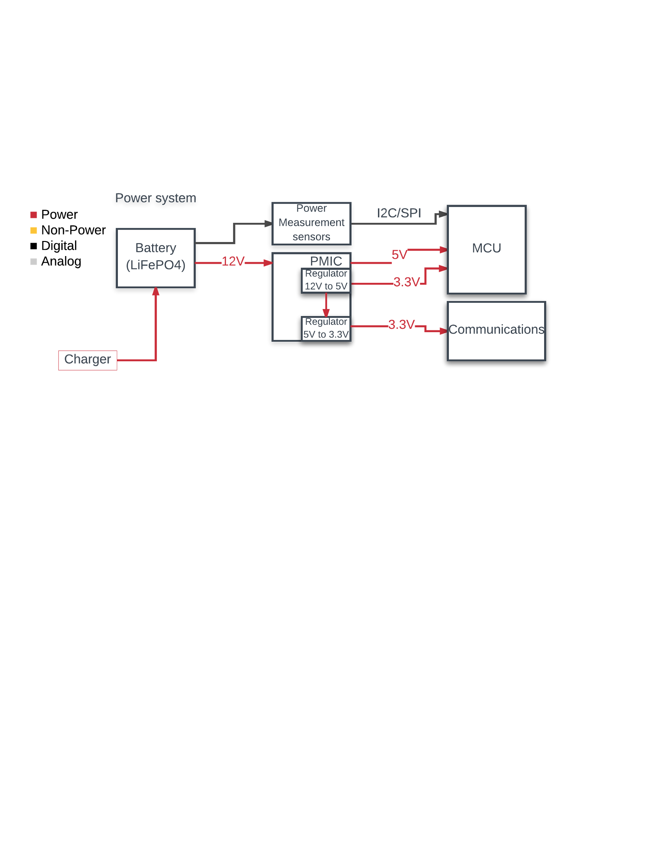

|  |  |
| --- | --- |
| **Component** | **Battery** |
| Inputs | Charger |
| Outputs | 12V voltage |
| Functionality | Power source for the entire system |

|  |  |
| --- | --- |
| **Component** | **Power measurement sensors** |
| Inputs | Battery output power |
| Outputs | I2C/SPI |
| Functionality | Measures battery status (output power) and sends it to MCU to analyze power consumption. |

|  |  |
| --- | --- |
| **Module** | **Power management integrated circuit (PMIC)** |
| Inputs | 12V |
| Outputs | 5V, 3.3V to MCU and Communication Units |
| Functionality | Providing management of output power, creating multiple stages of output voltages for charging and MCU power input. |

## ***Communications***

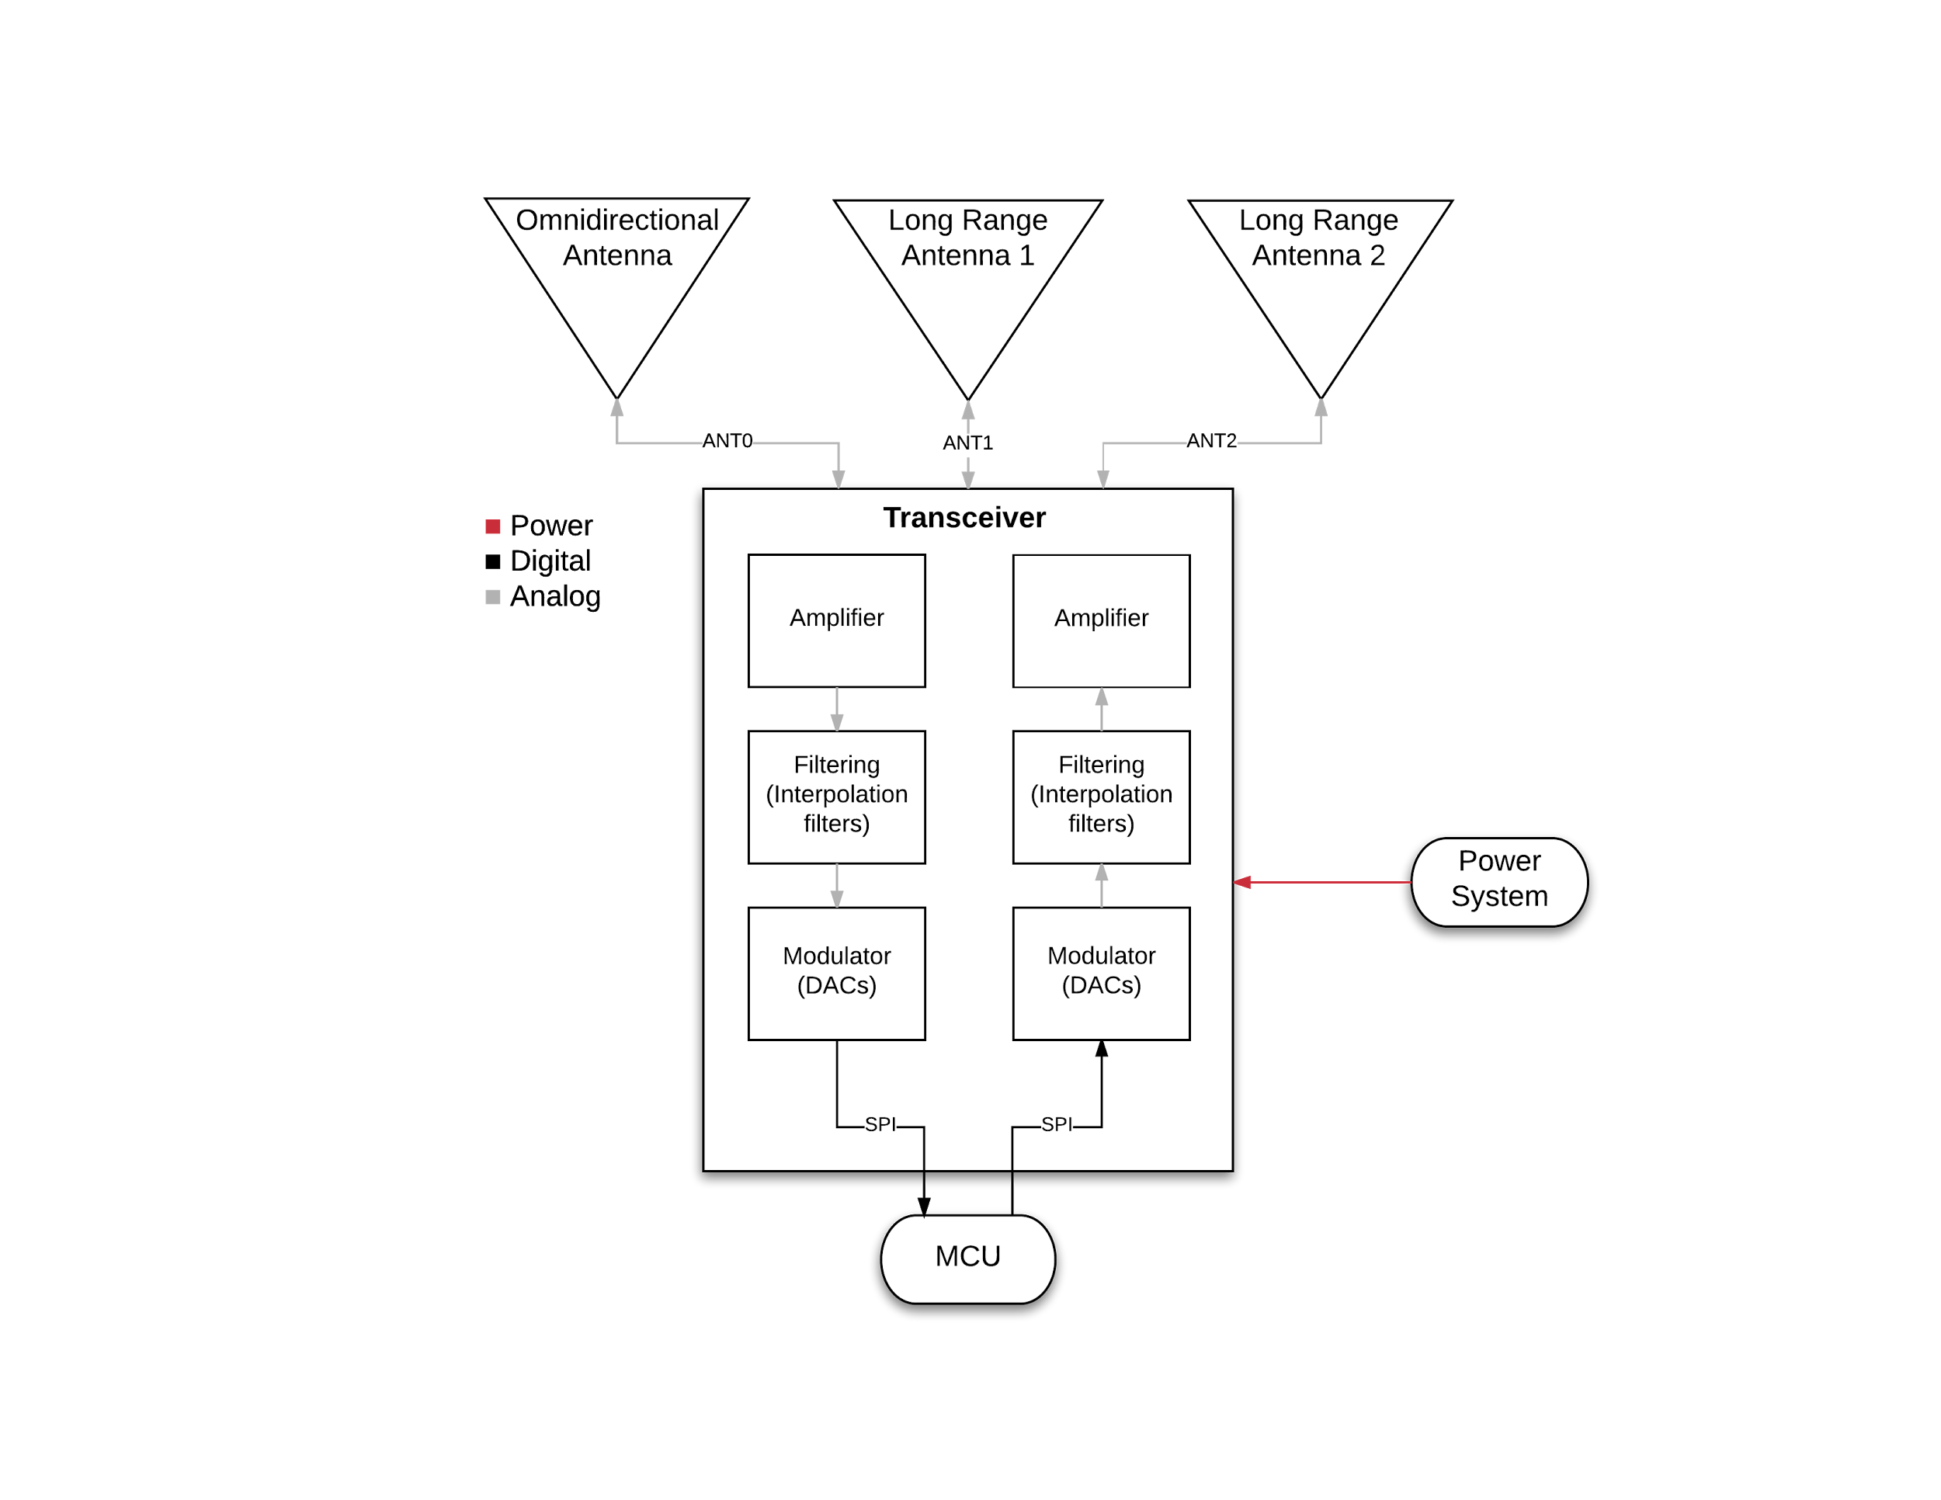

|  |  |
| --- | --- |
| **Component** | **Transceiver** |
| Inputs | Electricity from Power System, SPI from MCU, ANT0, ANT1, ANT2 |
| Outputs | SPI to MCU, ANT0, ANT1, ANT2 |
| Description | Transmit modulated signal and receive analog signals. |

|  |  |
| --- | --- |
| **Component** | **Omnidirectional Antenna** |
| Inputs | ANT0 |
| Outputs | ANT0 |
| Description | Generate radio waves covering a limited area. |

|  |  |
| --- | --- |
| **Component** | **Long Range Antenna (x2)** |
| Inputs | ANT1 or ANT2 |
| Outputs | ANT1 or ANT2 (same as input) |
| Description | Generate single direction radio wave. |